**Sana’a**

**UNIVERSITY**



**FACULTY OF ENGINEERING**

**Mechatronics Department**

**Second Year**

**Report**

**Academic Report About (C Language)**

**Supervision**

Prof. Sami ALmaqtry

Eng. Asil

# Adopted by

**Ibrahim Alkhlydy 202073007**

**Abstract**

The Phonebook Mini Project in C is a console-based application written in the C programming language. This system is a simple little project that was created in the Code: Blocks IDE and compiled with the GCC compiler. The Phonebook app has a few basic features for adding, searching, updating, and removing new contacts. … Functions, file management, and data structure are all used. This application describes how to add, view, alter, receive, and delete data from and to files. This system can be used by the schools, bus company, government agencies, office, and company that can monitor daily activities. You will always have access to your contacts, whether you are at work or at home. The basic goal of a phonebook application is to locate a person’s or organization’s address in a short amount of time.

Contents

Adopted by 0

Chapter 1 INTRODICTION TO C LANGUGAUE 1

1.1 BACKGROUND 1

1.2 Project Details and Technology 1

Chapter 2 Why to use Phonebook 2

2.1 BACKGROUND 2

2.1.1 Definitions 2

2.2 What is the importance of phonebook management system? 2

Chapter 3 Coding of project 3

3.1 Major Functionalities Used in Phonebook Management System in C 3

3.1.1 MAIN MENU 3

3.1.2 ADD NEW PHONEBOOK 3

3.1.3 LIST OF PHONEBOOK 4

3.1.4 MODIFY RECORD 4

3.1.5 SEARCH PHONEBOOK RECORD 5

Chapter 4 Flow Chart 6

4.1 Flow Chart 6

Chapter 5 Conclusion 11

Chapter 6 Bibliography 12

Figure 1Explain of MAIN MENU 3

Figure 2Explain of ADD NEW PHONEBOOK 3

Figure 3Explain of LIST OF PHONEBOOK 4

Figure 4Explain of MODIFY RECORD 4

Figure 5 Explain of SEARCH PHONEBOOK RECORD 5

Chapter1 Introduction to C Language

# INTRODICTION TO C LANGUGAUE

## BACKGROUND

## Project Details and Technology

The project’s name is Phonebook Management System, and the following are the project’s details and technologies: The project was written in C. The language used is C. Sourcecodehero.com is the project’s developer, and Dev- or Code Blocks are the recommended IDEs for this project, which is a desktop application. The database of this system only stores data in.DAT files.

This system can be used by the schools, bus company, government agencies, office, and company that can monitor daily activities. The Phonebook app has a few basic features for adding, searching, updating, and removing new contacts. … Functions, file management, and data structure are all used. This application describes how to add, view, alter, receive, and delete data from and to files. his program will show you how to add, list, edit or alter, look at, and delete data from a record. When adding a record to the Phonebook, personal information such as name, gender, father’s name, contact number, postal code, email, and address is requested. These records might be changed, recorded, searched for, and deleted.

Chapter2 Why to use Phonebook

# Why to use Phonebook

## BACKGROUND

### Definitions

This simple C Phonebook Mini Project creates an external file to permanently store the user’s data and conduct file handling activities. Phonebook is a very simple C project that will help you understand the core concepts of capacity, record keeping, and data structure. The Phonebook app has a few basic features for adding, searching, updating, and removing new contacts. … Functions, file management, and data structure are all used. This application describes how to add, view, alter, receive, and delete data from and to files.

## What is the importance of phonebook management system?

You will always have access to your contacts, whether you are at work or at home. The basic goal of a phonebook application is to locate a person’s or organization’s address in a short amount of time. For example, we can look up a person using their name, address, email, phone number, or location.

Chapter3 Coding of project

# Coding of project

## Major Functionalities Used in Phonebook Management System in C

### **MAIN MENU**

When you start the project from any compiler or by double-clicking the executable.exe file, you’ll see the screen shown below is main screen window.

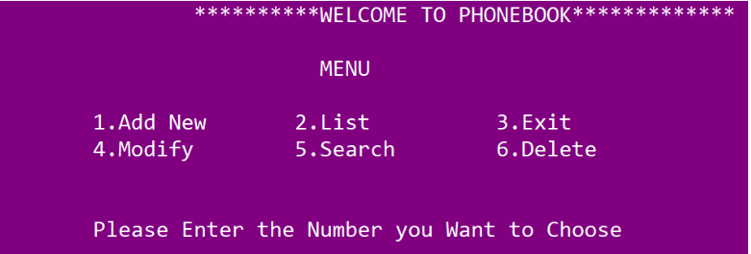

Figure 1Explain of MAIN MENU

### ADD NEW PHONEBOOK

In the image below is the example of adding new phonebook in the database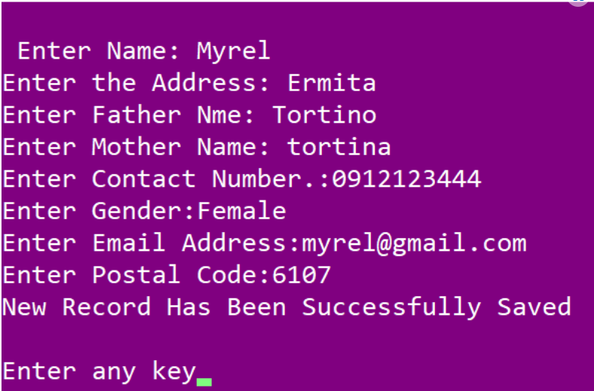

Figure 2Explain of ADD NEW PHONEBOOK

### LIST OF PHONEBOOK

In the image below is the example of viewing the list of phonebook in the database.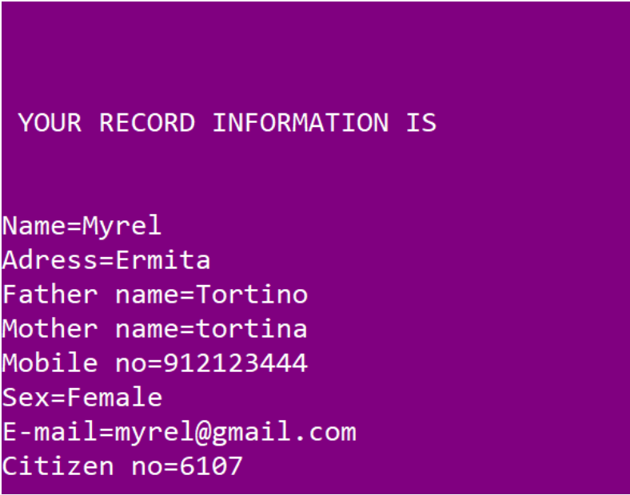

Figure 3Explain of LIST OF PHONEBOOK

### MODIFY RECORD

In the image below is the example of updating the phonebook information in the database.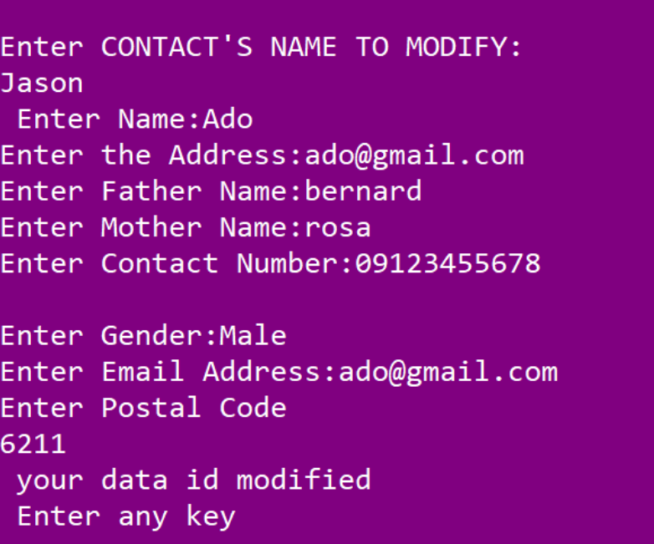

Figure 4Explain of MODIFY RECORD

### SEARCH PHONEBOOK RECORD

In the image below is the example of searching the phonebook information in the database.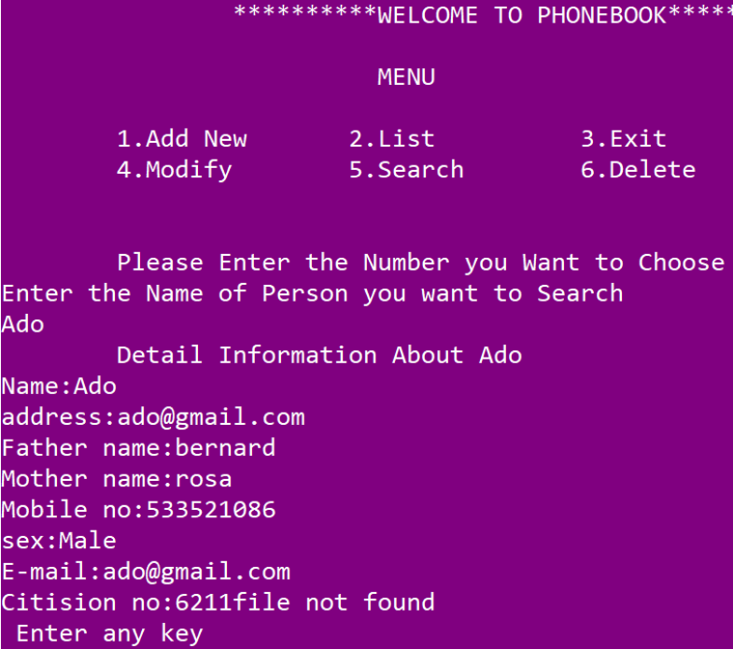

Figure 5 Explain of SEARCH PHONEBOOK RECORD

Chapter4 Flow Chart

# Flow Chart

## Define of arrays

char name , char address , char father_name char mother_name

long int mble_no , char sex ,char ma ,char citision_no

## Define of Function

void menu(); void got(); void start(); void back();

void addrecord(); void listrecord(); void modifyrecord(); void deleterecord();

void searchrecord();

## Flow Chart

Start

Print WELCOME TO PHONEBOOK

Switch getch

Case2

Case3

Case4

Case5

Case6

Case1

deleterecord

searchrecord

addrecord

listrecord

exit

modifyrecord

Enter 1 to 6 only

void addrecord

printf Enter name

got p.name

printf Enter the address

got p.address

Fclose (f)

printf Enter any key

void listrecord

if(f==NULL)

Printf file opening error in listing

exit(1)

void searchrecord

if(f==NULL)

exit(1)

Printf file opening error in listing

Printf ( Enter name of person to search

While (fread(&p,sizeof(p),1,f)==1)

if(strcmp

Printf tDetail Information About %s",name

else

Print file not found

Fclose (f)

printf Enter any key

void deleterecord

Printf CONTACT'S DATA NOT ADDED YET

f=fopenproject","rb

else if

Printf CONTACT'S DATA NOT ADDED YET

if(f==NULL)

Print file opaning error

else

if

If strcmp(p.name,name)!=0

If strcmp(p.name,name)==0

while

If flag!=1

else

Print NO CONACT'S RECORD TO DELETE

Print rECORD DELETED SUCCESSFULLY

void modifyrecord

int flag=0

Print CONTACT'S DATA NOT ADDED YET

if(f==NULL)

exit(1)

Print Enter any key

else

exit(1)

while

if

flag=1

Print Enter the address

got s.address

print Enter father name

got s.father_name

print Enter mother name

got s.mother_name

End

# Conclusion

This Phonebook Management System Project in C with Source Code is a project created only for the purpose of meeting educational requirements. For a semester project, I developed a Phonebook Management System in C Language. Its goal is to provide newcomers with a solid foundation in programming small to large projects by providing useful and practical information about C. You can download this program and alter it to meet your client’s needs; however, because this is a student effort, you shouldn’t expect it to be completely working.

# Bibliography

|  |  |
| --- | --- |
| [1] | Rajinikanth, "Btech Smart Class," [Online]. Available: http://www.btechsmartclass.com/c_programming/introduction-to-c-programming.html. [Accessed 18 03 2022]. |
| [2] | D. Hemmendinger, "Britannica," [Online]. Available: https://www.britannica.com/technology/C-computer-programming-language. [Accessed 18 03 2022]. |
| [3] | tutorialspoint, "Simply Easy Learning," 2014. [Online]. Available: https://www.tutorialspoint.com/ansi_c/c_introduction.htm. [Accessed 18 03 2022]. |
| [4] | B. Thomposn, "Guru99," 12 02 2022. [Online]. Available: https://www.guru99.com/c-programming-language.html. [Accessed 18 3 2022]. |
| [5] | P. Labs, "Programiz," [Online]. Available: https://www.programiz.com/c-programming. [Accessed 18 03 2022]. |